**IT Develoments: Project 2**

**Group Members:**

* **GN Mohutsiwa, 32937423**
* **NA Nkomo, 30974232**



Table of Contents

Project 2

1. List of figures

2. System web overview

3. Overview of technlogies used

4. ERD

5. Use Case

6. Data Flow Diagram

7. User guide

8. Team Dynamics…………………………………………………………………………………………………………….

System web overview

There is a need for the system web application, hence our duty is to build a system web application that will be able to let our user to create an account that will let them view, share and delete photos with a different user. Firstly, the user and their friend (someone our user will share his/her photos with) must create an account. This will be an online website to allow friends to connect and share photos. As a user you can only the photos of someone if they allow you to, they must give you a permission to access the photos.

The user must also create and manage their metadata for all the photos they have access to, they will also able to share content with the other registered users. The web system that is to be created will allow the users to download the photos they share. We tend to make our system will be user friendly. Above all, the user will have an update option, it will allow the user to update their albums.

Overview of technologies used

We are using visual studio, since well it will enable us to create a well web development project. Visual studio will enable us to use its server for our web project and it also has all the tools required for this system. Visual studio is mainly used for websites and our system must be an online platform. Hence creating an online system in visual studio will be much easier with visual studio.

ERD

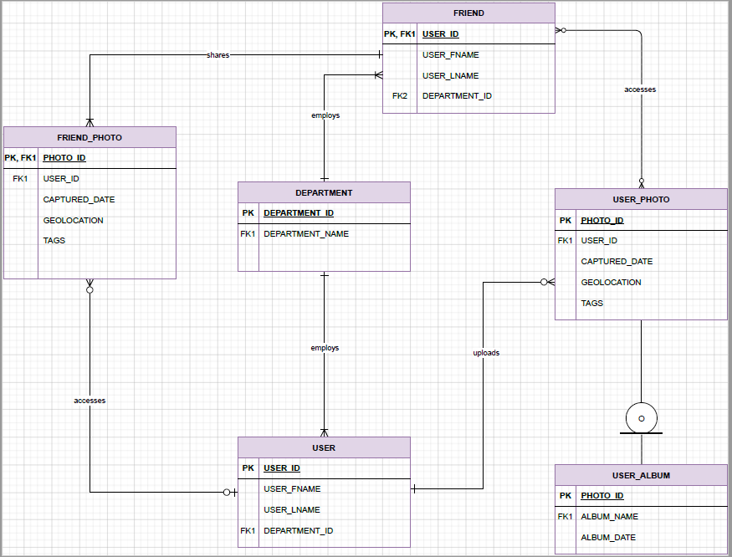

* There is a user, that is supposed to login first so that they access their photos. And then after logging in the user will uploads their photos to the system. That user photos will go to the albums of the user and only the user can see those albums.
* A friend is also supposed to register for them to share their photos with the user, a friend can share one to many photos, and a user can access zero to many photos of their friend. A friend must also get a permission to be able to access the photos they get from our user.

Use Case

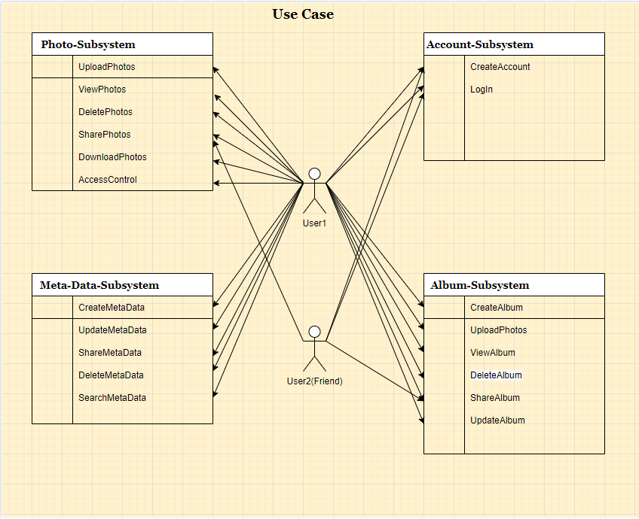

Our system web goal, is to upload, share, view and delete photos. The above use case consists of four sub systems, allows with its attributes. As indicated by the arrows, the user has a lot of duties under each sub system. They must first create their account and then log in, for them to be able to log in and start using the system. They will login with their username and password. The user will then create the album so that they can start upload their photos. He/she will upload the photos in their albums, as they share their photos, they will get to share their metadata but only if they want to. After viewing and deleting photos, they will update everything.

User2 must also create an account for them to be able to share the pictures, but then they have access to the shared pictures.

Data Flow Diagram

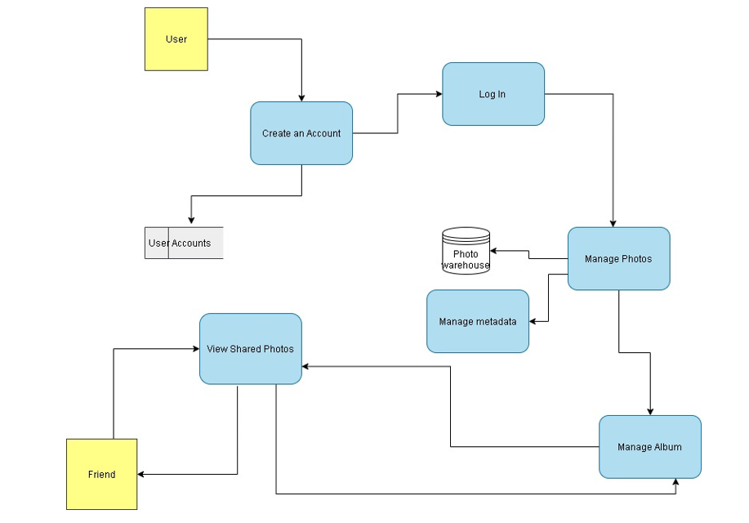

Our photo system web consists of five processes, two external entities and two data stores. Based on our data flow diagram; a user will create an account. And the user’s data will be store into the accounts. The user’s information will be processed so that the user can log in. After logging in, there comes a process of “manage photos”. In this case, the user will upload the photos, view them, delete some of them and share them to their friend. The photos will all be stored in a photo warehouse. While managing photos, that is where the manage metadata process comes in.

Manage photo process leads to two processes that includes manage photo and manage album processes. Manage metadata process includes creating, viewing, deleting, sharing and updating the metadata, and then manage album process includes creating an album, and then uploading the photos on it; and those albums can also be shared by the user. Then we have a view shared photos process that will allow either the user or their friend to view the shared photos.

User guide

Team Dynamics